Step to setup Tetrraform:

1. Goto github <https://github.com/ashish-mt05/terraform-zero-to-hero>
2. Then click on clone.
3. Then click on codespaces
4. Click on + icon then one new window will open.
5. In search box type “> dev” then click on “Codespaces:add Dev Configuration Container file.. ”
6. Then click on modify your active directory
7. Then search Terraform and then select Terraform, tfint, and TFGrunt devconatines

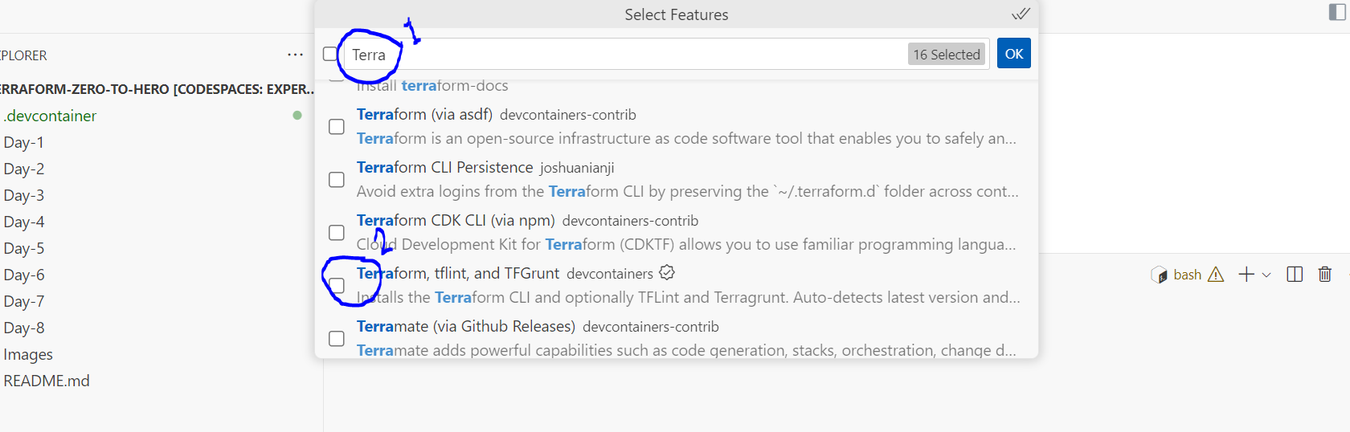

1. After selecting Then click Ok button.
2. Click on ‘’keep default’’
3. In search box type “> dev” then click on “Codespaces:add Dev Configuration Container file.. ”
4. Then click on modify your active directory
5. Then search aws and then select Terraform, tfint, and TFGrunt devconatines

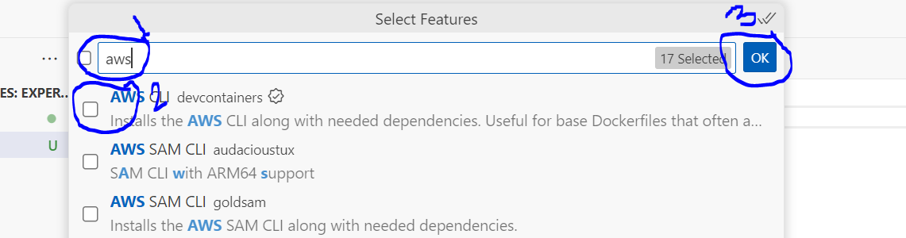

1. Then click Ok.
2. Click on ‘’keep default’’
3. Then search >rebuild Then select Codespaces: rebuild container.
4. You will get one popup page click on rebuild.
5. Once rebuild started you will get like this page.

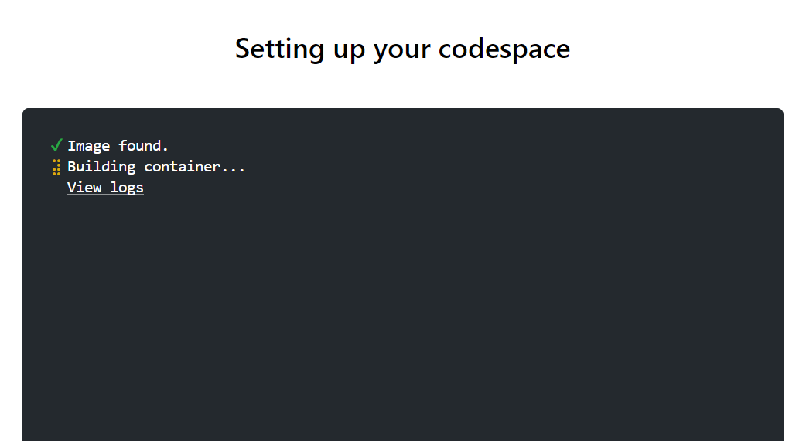

1. Once rebuild is done you will get:

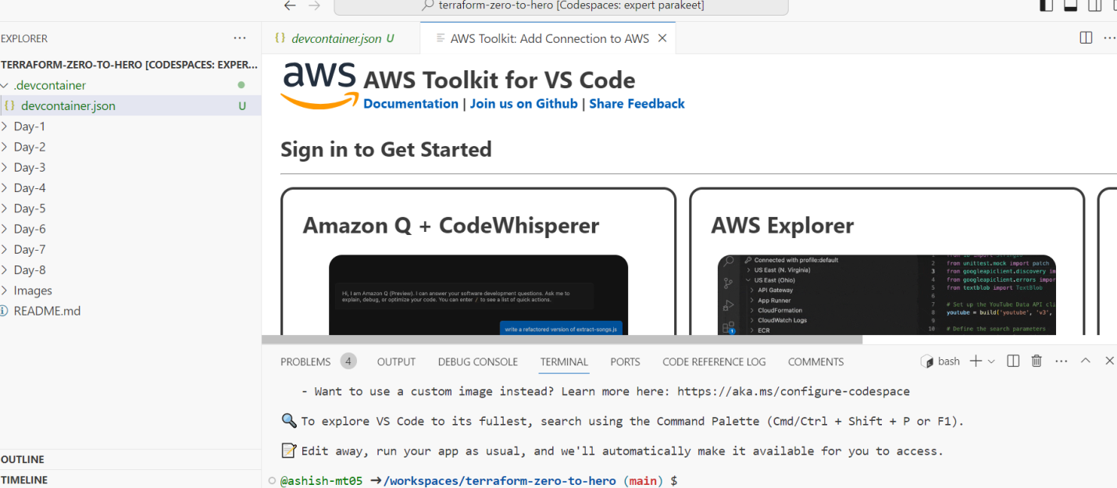

1. Once terraform and aws install you can check version:

* Terraform –version
* aws --version